007

|  |  |
| --- | --- |
| EXERCICES | POINT |
| Exercise 1 | 10 |
| Exercise 2 | 10 |
| Exercise 3 | 15 |
| Exercise 4 | 15 |
| Exercise 5 | 50 |
| **TOTAL** | **100** |

**Exercise 1:**

The alphabet is given below to help you:

a b c d e f g h i j k l m n o p q r s t u v w x y z

**Q1** What is the missing letter in this series? នៅក្នុងជួរខាងក្រោមនេះ​ តើអ្នកបាត់អក្សរអ្វី?​

a z b ? c x

Your answer: ______y_________

**Q2** What is the missing letter in this series?

a c f ? o u

Your answer: _________j______

**Exercise 2:**

**Q1** An ASCII represents 128 characters. What is the size (in bits) of an ASCII? *(Justify your answer)* ASCII តំណាងឲ្យ​ 128 តួអក្សរ។​ តើត្រូវការទំហំចំនូនប៉ុន្មាន​ (in bits)​​ នៃ​ ASCII?

* 1 bit = 21  =2 characters
* 2 bits = 22 = 4 characters

..........

..........

* 7 bits = 27 = 128 characters

So : 128 characters we need 7 bits to represent.

**Q2** With 12 bits, how many values can be represented? *(Justify your answer)*​ តើមានតម្លៃប៉ុន្មានដែលអាចដាក់បាន *12bits*?

* With 7 bits we need 27 = 128 values to represent

So : with 12 bits we need 212 = 4096 values to represent

**Exercise 3:**

**Q1** What is the result of this operation with binary numbers?​ តើចម្លើយរបស់អ្នកស្មើប៉ុន្មាន បន្ទាប់ពីការធ្វើប្រមាណវិធីដក​លេខប្រព័ន្ធគោលពីរ?

111101

- 010011

- 011010

Your answer: ___10000________

**Q2** What is the result of this operation with hexadecimal numbers? ?​ តើចម្លើយរបស់អ្នកស្មើប៉ុន្មាន បន្ទាប់ពីការធ្វើប្រមាណវិធីបូក​លេខប្រព័ន្ធគោលដប់ប្រាំមួយ?

A4F8

+ FF44

+ BCDE

Your answer: ____2611A___________

**Exercise 4:**

Compute the following conversions

|  |  |
| --- | --- |
| Base 16 | Base 10 |
| EF5 | EF5(16) = 1110 1111 0101(2)  = 3829(10) |

|  |  |
| --- | --- |
| Base 10 | Base 8 |
| 78 | 78(10) = 001 001 110(2)  = 116(8) |

**Exercise 5:**

We have the following kind of texts:

*Example 1*

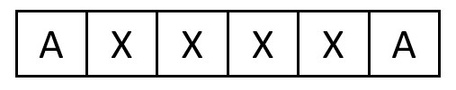

*Example 2*

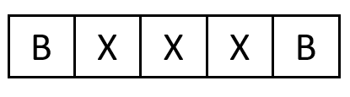

*Example 3*

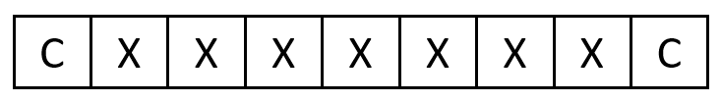

Text rules:

- The **first** and last **characters** can be **characters:** A, B, C or D

- The **first** and last **characters** havethe **same value**

- The text contains **at least 2 characters**

- All characters in the middle are **X**

- The number of **characters** in the middle can change from 0 to 20

ច្បាប់អត្ថបទ៖

* តួអក្សរដំបូង និង​ តួអក្សរចុងក្រោយអាចជាតួអក្សរ: A, B, C or D
* តួអក្សរដំបូង​​ និង​ តូអក្សរចុងក្រោយមានតម្លៃដូចគ្នា
* អត្ថបទត្រូវមានយ៉ាងហោចណាស់ ពីរតូអក្សរ
* តួអក្សរទាំងអស់ដែលនៅកណ្ដាលគឺជាអក្សរ X
* ចំនូននៃតួអក្សរដែលនៅកណ្ដាលអាចផ្លាស់ប្ដូរចាប់ពី លេខសូន្យ (0)​ ទៅ​ លេខម្ភៃ (20)

**Q1** Find an encoding so that the text size **cannot exceed 7 bits.** ស្វែងរក **encoding** ដែលធ្វើឲ្យទំហំអត្ថបទមិនអាចលើសពី **7bits**។

* Explain the different parts of your encoding. ពន្យល់ពីផ្នែកខុសគ្នានៃ encoding របស់អ្នក។

|  |  |  |
| --- | --- | --- |
| Meaning | Encoding decimal | Encoding binary |
| Character : A,B,C,D | A : 0  B : 1  C : 2  D : 3 | 0  1  10  11 |
| number of **characters** in the middle | 0 : 0  .....  20 : 20 | 0  .....  10100 |

* Explain the size of your encoding. គណនាទំហំនៃ encoding របស់អ្នក។

AXXXXX...A = 0 10100

**20**

**Q2** Is your encoding LOSSLESS or LOSSLY? *(Justify your answer)*​​

My encoding is lossless, because I can store information that I inputed.